IALD Presents Merit Award for Restoration of Paseo del Ovalo, Escalinata
Artecluminotecnia Accepts Award
New York, NY, April 13, 2005 – At its 22nd Annual IALD Awards Presentation, the International Association of Lighting Designers (IALD) is pleased to present an Award of Merit for Restoration of Paseo del Ovalo, Escalinata and its surroundings in an historic two-level public plaza in Teruel, Spain. The entry was judged in the site/façade category. This year, 15 projects earned awards of merit, and three of them were in the site/façade category. Principal lighting designer on the project is Maurici Gines of Artecluminotecnia located in Barcelona, Spain. Other lighting designers credited on the project are Jose Cardona, Javier Manzur and Eduardo Oyhenart.
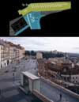 | 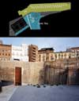 |  |  | 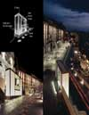
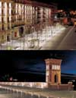 | 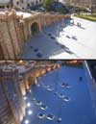 | 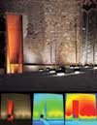 | 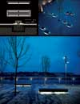 | 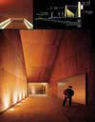
The major design challenge was to provide a fresh, unifying look that injected new life into the historic space while respecting the traditional structures. The designers played with light and dark spaces so that new space emerges when people are simply strolling or sitting in the plaza. For example, LED dots now guide visitors to the station’s dramatic entrance and benches are illuminated from below by compact fluorescent lamps.
The design exemplifies very nice composition,” said one judge. “It is extremely pleasing and functional — for lighting as much as finding one’s way.”
At this year’s 22nd annual event, the IALD awarded 23 projects that represented six of the seven categories. Fifteen projects earned IALD Awards of Merit, two in both the hospitality and corporate categories, three in the site/façade category, and four in each the retail/entertainment and monumental structures/public spaces categories. Seven IALD Awards of Excellence were also awarded: one in both the corporate and retail categories; two in site/façade; and three in the category of monumental structures/public spaces. The highest point earner wins the Radiance Award for Excellence in Architectural Lighting Design. An IALD Special Citation for innovative use of materials and techniques for daylighting control was granted for an entry in the academic/institutional category.
The IALD Lighting Design Awards program, established in 1983 and co-sponsored by Professional Lighting Design magazine, honors lighting projects that display high aesthetic achievement backed by technical expertise. Entries are submitted into one of seven categories: Academic/Institutional; Corporate; Hospitality; Monumental Structures/Public Spaces; Residential; Retail/Entertainment; and Site/Façade. Additionally, projects can also be submitted for consideration in the sustainable design award category, which means the project undergoes an additional round of judging keyed solely to the fulfillment of sustainable design principles. A panel of award-winning lighting designers and architects review the projects.
This year, the IALD received 141 submissions from 14 countries. The IALD, established in 1969, is an international organization dedicated to the profession of architectural lighting design. Based in Chicago and comprised of 700 members throughout North and South America, Europe, Asia and Australia, the IALD’s role is to set the global standard for lighting design excellence.
Additional information can be downloaded from www.IALD.org

